INGALLS FIELD (KHSP), Hot Springs, VA
Created by Real-world Pilots for FSX Simmers
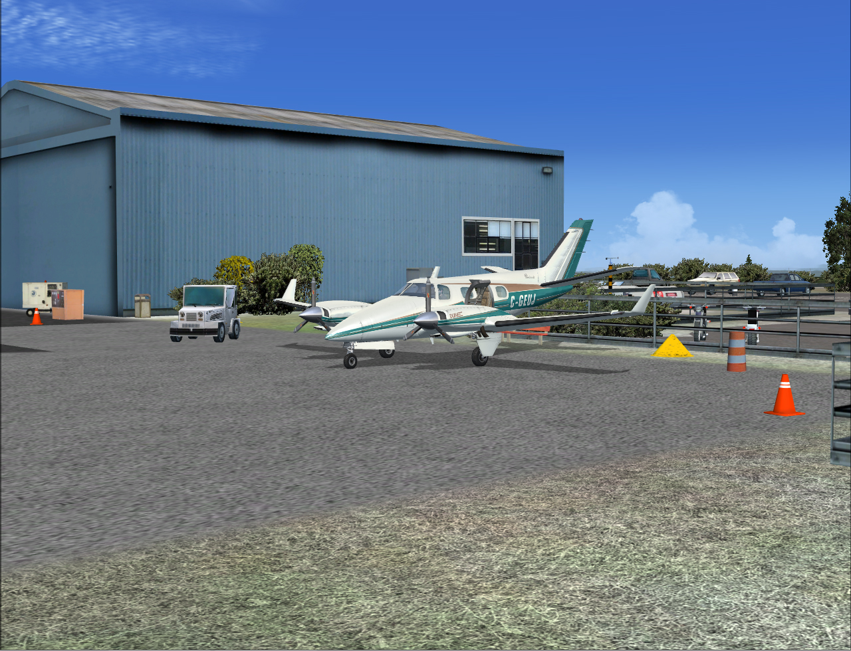

Graham Michael
Lead Software Design

Pacific Islands Simulation
Martinsburg, West Virginia USA

www.islandsim.com
http://islandsim.com/pis_forum/
Product Support email: toksawe@gmail.com

© 2010 All Rights Reserved

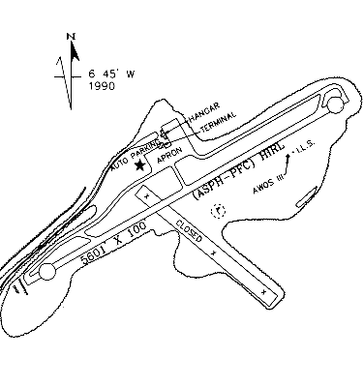
BACKGROUND
Ingalls Field is a small Virginia airport perched atop the Warm Springs Mountain ridgeline at near 4000ft (1219m) amsl. It is the highest public use airport east of the Mississippi with a single 5600ft (1707m) runway. As one local news reporter covering the airport summarily described, "...it's so inconspicuously located truly in the middle of nowhere that many county residents don’t even know it’s there." (Most county residents live below the ridgeline, hence "out-of-sight-out-of-mind").
Although the airport has only 3 employees, Ingalls Field has served many general aviation needs and special guests over the years. Apart from playing host to President Bill Clinton, who arrived on a DC-9 in the Winter of 2000, the airfield continues to accommodate general aviation aircrafts with an average 31 aircraft per day. From 2009 stats, 81% of these are transient, 12% military and 8% local traffic.
Because the airport is situated atop the ridgeline with an aircraft carrier-type runway (drop off at each end) and unforgiving wind shear factors, it is an ideal location for military operations including aircraft testing and intermittent Touch and Gos. According to the airport engineer, wind shear frequently occurs at the airport when wind hits the side of the mountain and rides up one side and goes down on the other. If not careful or fully aware, an aircraft that flies into the wind current gets pushed down along with it.

In 1976, Ingalls Field had its only major airport tragedy due to bad weather (low visibility) when an aircraft carrying 11 people collided with the mountain 500ft below the runway. The pilot with 11 executives of Johnson and Johnson company made 2 failed landing attempts before striking the mountain on the 3rd killing all on board.

PRODUCT DESCRIPTION
Ingalls Field has been thoroughly overhauled from its default FSX version to resemble its real-world counterpart. The resulting product is from multi sources including pictures and anecdotes from pilots, unknown photographers, local newspapers and the Airport Manager. The product package includes:
- Custom buildings (terminal and hangars)
- Custom tarmac/ground polys and textures
- Customized vegetation
- Custom objects (too many to list)
- Custom night effects on buildings and ground
- All season photo-real airport scenery at 30cm/pixels
- Re-adjusted airport terrain matching real-world
- AI rendered/enabled (road and aircraft traffic)
- Latest (03 June, 2010) airport specific data including Instrument/Nav charts
- Animation (birds within approach path, etc)
- Very friendly frame rates.

SYSTEM SPECIFIC REQUIREMENTS

Ingalls Field was developed on a low-end system for low to high-end computers, and was tested on WinXP, Vista and Win7 32/64 bit platforms with medium to high-end graphic cards. Specific requirements include:

- Microsoft Flight Simulator X (SP1, SP2/Acceleration)
- Pentium IV 2.6 GHz (2GHz Duo2Core Intel or equivalent advised)
- 1 GB RAM and above
- 256 Mb DirectX 9 graphics card (512 Mb or higher recommended)
- Adobe Acrobat® Reader 6 minimal to read and print the manual.
- 200 MB of disk space

INSTALLATION
The following set of installation and activation instructions does not apply to those who purchased from simmarket.com as the simmarket wrapper automatically installs and activate the product.

FOR WINXP OR VISTA OS:

After installation, fire up FSX and from the "World" drop down menu, select "Scenery Library" then click "Add Area." This will open up the main FSX folder. Scroll down to "PacSim" and double click to access "Ingalls Field." Then click once to bring you back to the Scenery Library. Click "OK" to activate.

FOR WIN7 OS:

1. Go to the "Scenery Library" in the "Settings" menu then browse thru main FSX folder to locate "PacSim" then click to access "Ingalls Field."

2. Select "Ingalls Field" then click "Add" and then click "OK."
Ingalls Field will not be added, instead it will advance inside the directory. To add the scenery LEFT click on any blank space inside the folder, and the windows should close. You should then see Ingalls Field listed in the scenery library.

AIRPORT FACTS, FIGURES AND CHARTS
(Source: www.airnav.com)
NOT FOR REAL-WORLD USE

FAA INFORMATION EFFECTIVE 03 JUNE 2010

Location
FAA Identifier: | HSP
Lat/Long: | 37-57-05.2000N / 079-50-02.0200W  37-57.086667N / 079-50.033667W  37.9514444 / -79.8338944  (estimated)
Elevation: | 3793 ft. / 1156.1 m (surveyed)
Variation: | 08W (2000)
From city: | 3 miles S of HOT SPRINGS, VA
Time zone: | UTC -4 (UTC -5 during Standard Time)
Zip code: | 24460

Airport Operations
Airport use: | Open to the public
Activation date: | 10/1937
Sectional chart: | CINCINNATI
Control tower: | no
ARTCC: | WASHINGTON CENTER
FSS: | LEESBURG FLIGHT SERVICE STATION
NOTAMs facility: | HSP (NOTAM-D service available)
Attendance: | APR-OCT MON-FRI 0800-1800, APR-OCT SAT-SUN 0800-1800, NOV-MAR 0900-1700
Wind indicator: | lighted
Segmented circle: | yes
Lights: | DUSK-DAWN  ACTVT HIRL RY 07/25, PAPI RYS 07 & 25, REIL RY 25, & TWY LGTS - CTAF.
Beacon: | White-green (lighted land airport)
Landing fee: | yes, LDG FEE WAIVED FOR FUEL PURCHASE MULTI ENGINE ACFT ONLY.

Airport Communications
CTAF/UNICOM: | 123.0
WX AWOS-3: | 118.8 (540-839-5974)
- APCH/DEP SVC PRVDD BY WASHINGTON ARTCC ON FREQS 134.4/353.9 (BUENA VISTA RCAG).

Nearby radio navigation aids
VOR radial/distance |  | VOR name |  | Freq |  | Var
LWBr087/26.9 |  | GREENBRIER VOR/DME |  | 116.05 |  | 08W
MOLr280/34.5 |  | MONTEBELLO VOR/DME |  | 115.30 |  | 05W
ROAr021/38.2 |  | ROANOKE VORTAC |  | 109.40 |  | 04W
ODRr016/(38.3) |  | WOODRUM VOR |  | 114.90 |  | 06W

Airport Services
Fuel available: | 100LL JET-A
Parking: | hangars and tie-downs
Airframe service: | NONE
Powerplant service: | NONE
Bottled oxygen: | NONE
Bulk oxygen: | NONE

Runway Information

Runway 7/25
Dimensions: | 5600 x 100 ft. / 1707 x 30 m
Surface: | asphalt/porous friction courses, in good condition
Weight bearing capacity:
  Single wheel: | 65.0
  Double wheel: | 160.0
Runway edge lights: | high intensity
 | RUNWAY 7 |  | RUNWAY 25
Latitude: | 37-56.848398N |  | 37-57.325910N
Longitude: | 079-50.531672W |  | 079-49.534983W
Elevation: | 3792.7 ft. |  | 3763.0 ft.
Gradient: | 0.5% |  | 0.5%
Traffic pattern: | Left |  | left
Runway heading: | 067 magnetic, 059 true |  | 247 magnetic, 239 true
Markings: | precision, in fair condition |  | precision, in fair condition
Visual slope indicator: | 4-light PAPI on right (3.00 degrees glide path) |  | 4-light PAPI on left (3.00 degrees glide path)
Runway end identifier lights: |  |  | yes
Touchdown point: | yes, no lights |  | yes, no lights
Instrument approach: |  |  | ILS
Obstructions: | 32 ft. gnd, lighted, 200 ft. from runway, 200 ft. right of centerline  07 +32 FT HIGH TERRAIN 200 FT FM RY END 200 FT RIGHT. |  | none  RY 25 HAS +20 FT TREES 400 FT L & R CNTRLN.

Airport Operational Statistics
  Aircraft based on the field: |  | 4
  Single engine airplanes: |  | 2
  Jet airplanes: |  | 1
  Helicopters: |  | 1
  Aircraft operations: avg 31/day *
  81% | transient general aviation
  12% | military
  8% | local general aviation
  * for 12-month period ending 31 May 2009

Additional Remarks
- | WILDLIFE, INCLUDING BEAR, ON & INVOF ARPT.
- | BE ADVISED LOW PASS TO CHECK/CLEAR WILDLIFE WHEN ARPT UNATNDD.

DOWNLOAD INSTRUMENT AND NAVIGATIONAL CHARTS AT

http://islandsim.com/pis-forum-and-downloads.html

