JEJU INTERNATIONAL

Created by Real-world Pilots for FSX Simmers

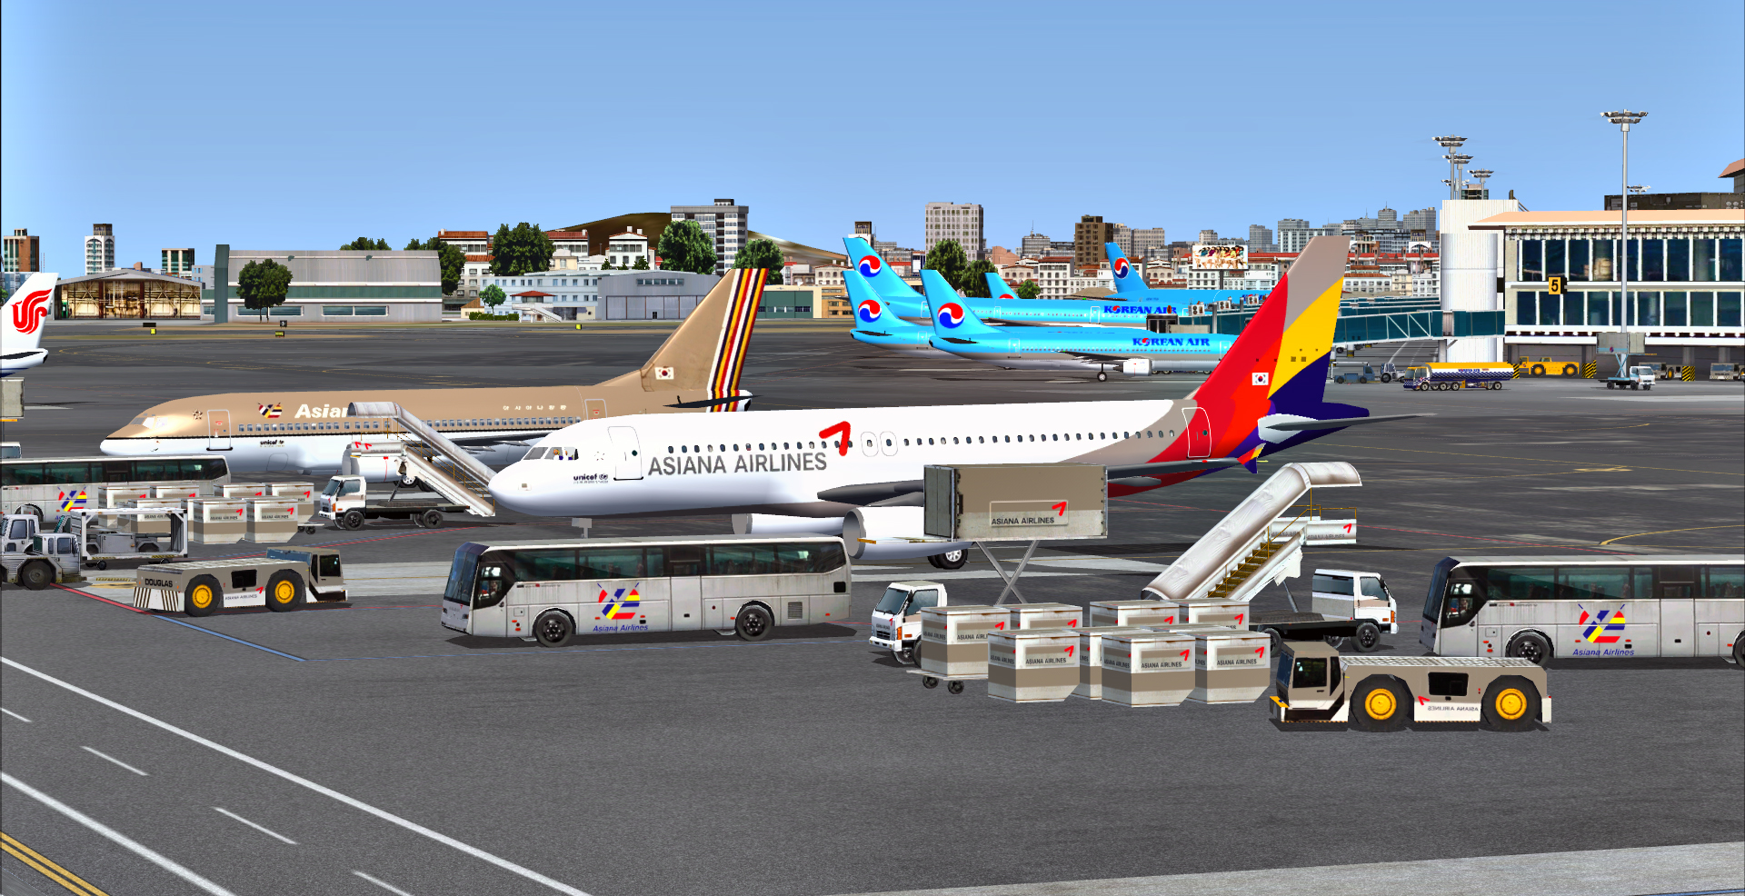

Graham Michael
Lead - Software Design & Development

Pacific Islands Simulation, LLC
Martinsburg, West Virginia USA

www.islandsim.com
www.islandsim.com/pis_forum
toksawe@gmail.com

© 2012 All Rights Reserved

A. BACKGROUND

Jeju International Airport (IATA: CJU, ICAO: RKPC) is located on the volcanic island of Jeju, in Jeju-Do (Jeju province), South Korea. The island, also known as the "Island of the Gods," is a popular vacation spot for Koreans and many Japanese. It remains one of the top honeymoon destinations for Korean newlyweds. The island's mixture of volcanic rock, frequent rains, and temperate climate, make it very similar to the Hawaiian Islands in the U.S.

Jeju International Airport is situated beneath the shadow of South Korea's highest mountain Halla-san (Halla Mountain) which is 1,950 metres (6,400 ft) high. It is South Korea's third busiest airport (17,201,878 traffic in 2011) after Incheon and Gimpo. The airport serves daily domestic and international destinations through the following airlines:

Air Busan - Busan, Seoul-Gimpo

Asiana Airlines - Busan, Cheongju, Daegu, Fukuoka, Gwangju, Jinju-Sacheon, Muan, Pohang, Seoul-Gimpo, Seoul-Incheon

China Eastern Airlines - Beijing-Capital, Hangzhou, Nanjing, Ningbo, Shanghai-Pudong
Seasonal: Wuxi

China Southern Airlines - Changchun, Dalian, Shenyang
Charter: Harbin, Wuhan

Dragonair - Hong Kong

Eastar Jet - Cheongju, Gunsan, Seoul-Gimpo
Charter: Changsha, Chongqing, Hefei, Fuzhou, Hohhot, Macau, Nanning, Ningbo, Taiyuan, Chengdu, Guangzhou

Far Eastern Air Transport - Charter: Kaohsiung

Jeju Air - Busan, Cheongju, Osaka-Kansai, Seoul-Gimpo
Charter: Wenzhou

Jin Air - Seoul-Gimpo, Shanghai-Pudong, Taipei-Taoyuan
Charter: Harbin, Xi'an

Korean Air - Beijing-Capital, Busan, Cheongju, Daegu, Gwangju, Gunsan, Jinju-Sacheon, Osaka-Kansai, Nagoya-Centrair, Seoul-Gimpo, Seoul-Incheon, Tokyo-Narita, Ulsan, Wonju, Yeosu

T'way Airlines - Seoul-Gimpo

TransAsia Airways - Taipei-Taoyuan

: 2 :

B. AIRPORT INFORMATION

Latitude: 33.511299 | 33 30.677948 N | N33 30 40
Longitude: 126.492996 | 126 29.579773 E | E126 29 34
Field elevation: 118 ft/36 m MSL
Magnetic variation: 6.315°W

Communication frequencies

APP:119 MHz
ATIS:126.8 MHz
DEP:121.2 MHz
GND:121.65 MHz
MISC:120 MHz
TWR:118.1 MHz

Runways

07/25
9,843 x 148 ft (3,000 x 45 m)— paved— lighted

Note: Latest Korean AIS AIRAC indicates runway change from 06/24 to 07/25 effective September 20, 2012.

13/31
6,268 x 148 ft (1,910 x 45 m)— paved— lighted— threshold 31 displaced 1,350 ft (411 m)

More airport information including Charts can be found here: http://ais.casa.go.kr/

C. PRODUCT FEATURES

- Accurate airport terminal building and hangars;
- HD apron/tarmac textures
- Custom ground lighting system
- Custom vegetation;
- Realistic night lighting ambiance;
- 15cm/pixel photoreal landclass.
- Season coloration typical of the island;
- Static South Korean airport groubd vehicles and equipment;
- AI boats and road traffic
- Weathered runway and apron markings;
- Custom buildings within airport vicinity and city area;
- Framerate-friendly;
- ....and more.

: 3 :

D. SYSTEM-SPECIFIC REQUIREMENTS

Jeju International Airport was developed on a medium system for medium to high-end computers, and was tested on WinXP, Vista and Win7 32/64 bit platforms with medium to high-end graphic cards. Specific requirements include:

- Microsoft Flight Simulator X (SP1, SP2/Acceleration)
- Pentium IV 2.6 GHz (2GHz Duo2Core Intel and above or equivalent advised)
- 256 Mb DirectX 9 graphics card (512 Mb or higher recommended)
- Word for Windows or Adobe Acrobat® Reader 6 minimal to read and print the manual.
- 340MB of hard disk space required

E. RECOMMENDED FSX SETTINGS
Frame rates from scenery complexity and autogen settings were averaged at 40fps and above. This includes moving sliders 100% to the right. Medium settings yielded much higher frames, but our recommendation is Dense to Very Dense for exceptional rates. Since the scenery is 15cm/pixel photoreal, it is highly recommended that Mesh Resolution be set at 1 meter within FSX Display Settings (slider 100% to the right) and mesh complexity set at 100%. Texture Resolution should also be set at 30cm and above (or slider 100% to the right).
Recommended AI Traffic settings:

There are AI boat traffic off the coast of Jeju City.. To maintain exceptional FPS levels, it is recommended that leisure boats be set at 20% or less.

AI Road traffic should be set at 20% or less.

MyTrafficX (5.4) is our preferred AI traffic engine. However, the product is compatible with any other third party payware and/or freeware AI engines as well. Recommended setting for best performance is 60% or less.

F. PRODUCT DISCLOSURE and DISCLAIMER

Similar to any Flight Simulator (FS) Addons, this product may have issues that are either default (Microsoft-related) or developer-related. Issues that are MS-related, whether documented or undocumented are many, but we can only speak for our product. Although there are no micro-stutters or huge lag in fps as tested, it is advisable to lower the Water Effects within FSX Display Settings to High 2x. and set Autogen down to respectable levels for fluidity. These are recommended for lower to medium-end systems.

No technical issues were encountered during various beta tests, whether hardware or software- related. Instructions for installation of software are straightforward; however, venturing outside bounds of recommended installation and use is at sole discretion of End-User.

: 4 :

We will not bear responsibility for issues resulting from installation of the product, in part or full, into former Flight Simulator platforms which includes FS2004 because the product is not backward compatible. Furthermore, we will not be held responsible if files are altered within software for any reason associated with End-User taste or choice.

The product is Non-refundable for these and various other reasons.

G. ACKNOWLEDGEMENT

As usual, we are deeply grateful to those who contributed to development of this product. The list includes:

1. Soo-han Kim - for providing photos, Korean character translation and all information on Jeju International Airport. And for testing product
2. Captain Chankyu Kim - for photos and airport description
3. Jeongwoo Park - for conveyance of third party information and translation
4. Chung-Hee Hyun - for testing and pictures
5. Henry Pearce - for landclass and waterclass textures
6. Lance "Meshman" Tucker - for testing product
7. Ken Alger - for testing product
8. James Whitener - for testing product
9. Gregory Cedric - for testing product

…and to those I may have inadvertently left out in this Acknowledgement, we highly value your contribution as well.

Graham Michael
Lead - Software Design & Development

: 5 :

CHARTS

Charts courtesy of South Korean Aeronautical Information Service (AIS). For complete/required charts, go get them here:

http://ais.casa.go.kr/

Specific Charts included with the product are:

(2-26) SID(5)

(2-33) STAR(14)

(2-35) INSTR APCH CHART(3)

(2-25-1) VISUAL APCH CHART(3)

(2-24) AREA CHART(31)

