REPUBLIC OF NAURU INTERNATIONAL AIRPORT (ANYN)

Created by real-world Pilots for FSX Simmers

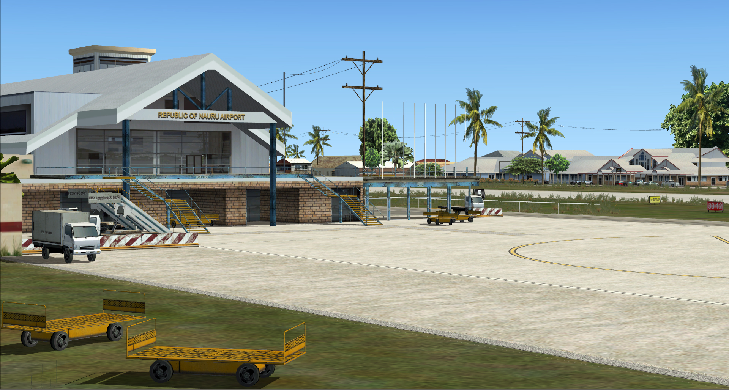

Graham Michael
Lead - Software Design & Development

Pacific Islands Simulation, LLC
Martinsburg, West Virginia USA

www.islandsim.com
www.islandsim.com/pis_forum
toksawe@gmail.com

© 2012 All Rights Reserved

: 1 :

A. GEO-POLITICAL BACKGROUND AND HISTORY

Formerly known as Pleasant Island, Republic of Nauru is the world's smallest republic and second least-populated country after the Vatican City. The country is just 21square kilometers (8.1sq m) with just over 9,320 residents.
Settled by Micronesian and Polynesian people, Nauru was annexed and claimed as a colony by the German Empire in the late 19th century. After World War I, Nauru became a League of Nations mandate administered by Australia, New Zealand, and the United Kingdom. During World War II, Nauru was occupied by Japanese troops, who were bypassed by the Allied advance across the Pacific. After the war ended, it entered into trusteeship again. Nauru gained its independence in 1968.
Throughout the first half of the 20th century, Nauru was a "rentier state". Nauru is a phosphate rock island, with rich deposits close to the surface, which allow for simple strip mining operations; moreover, it has some phosphate reserves which are presently (as of 2011) not economically viable for extraction. Nevertheless, this island was a major exporter of phosphate starting in 1907, when the Pacific Phosphate Company began mining there, through the formation of the British Phosphate Commission in 1919, and continuing after independence. This gave Nauru back full control of its minerals under the Nauru Phosphate Corporation, until the deposits ran out during the 1980s. For this reason, Nauru briefly boasted the highest per-capita income enjoyed by any sovereign state in the world during the late 1960s and early 1970s.
When the phosphate reserves were exhausted, and the environment had been seriously harmed by mining, the trust that had been established to manage the island's wealth diminished in value. To earn income, Nauru briefly became a tax haven and illegal money laundering centre. From 2001 to 2008, it accepted aid from the Australian Government in exchange for housing a Nauru detention centre that held and assessed the refugee claims of asylum seekers who had arrived unauthorised in Australia.
(Information courtesy of wikipedia: http://en.wikipedia.org/wiki/Nauru)

B. AIRPORT AND INTERNATIONAL AIR SERVICES

The island has one airport, Nauru International Airport. The airport is located in the Yaren district, just north of many of the government buildings, including the Parliament House, police station, and the secondary school. The airport was estimated to have cost US$12 million and has been up for sale since 1996, when the government ran out of money. It is currently on sale for $10 million. The money would be used to pay the nation's debt, which stands at $11 million 124% of GDP.

: 2 :

From January to September 2006, Nauru became partially isolated from the outside world when Air Nauru, the only airline which served the island, ceased operations in December 2005 and left the island accessible only by ship. The airline was subsequently able to restart operations in October 2006 under the name Our Airline with monetary aid from Taiwan. Current International flights to and from Nauru by Our Airline includes Brisbane, Australia and Honiara, Solomon Islands.

C. FACILITIES DIRECTORY
(NOT TO BE USED IN RW)

ICAO Code: ANYN IATA Code: INU

Coordinates | 00°32′50.85″S 166°55′08.76″E

RWY 12-30 H7,054x154.2ft /2150x47m (Asphalt) Elv. 12ft (7m)

Tower Ops: Day attended FT/Night at advance noticed.
RWY 12 lights Left VASI - PAPI2 type
RWY 30 lights Left VASI – PAPI2 type

Navaid. NI – VORDME. 113.0 195nm range
NI – NDB. 355.0 75nm range

Communication. TWR. 126.5
ARTCC Nauru. 125.5
ATIS. 118.1

Airport Remarks/NOTAM
- PPR for night landing by Airport Manager. Except Emergency, report within 48hrs.
- Constant crosswind daylight hrs
- Bird hazards on and near RWY
- Noise abatement after dusk

Airport Charts: None

______________________________________________________________________________

D. PRODUCT FEATURES

- Accurate airport terminal building;
- Custom 76m terrain mesh;

: 3 :

- Custom 3D-look runway with ground/tarmac HD textured;
- Custom vegetation typical of the tropics;
- 3D grass
- Full night lighting ambiance;
- 15/30 pixel photoreal texture. Complete hand textured land and waterclass coloration;
- Ambient sounds (wave crash);
- Framerate-friendly (including full autogen enhancements for framerate fluidity using SDK annotator). This means all sliders to the right with very minimal fps impact;
- Weathered runway and apron markings;
- Custom asphalt polygon roadway looping around the runway
- Very small file size suitable for low to medium computers;
- ....and more.

E. SYSTEM-SPECIFIC REQUIREMENTS

The Republic of Nauru International Airport was developed on a medium system for medium to high-end computers, and was tested on WinXP, Vista and Win7 32/64 bit platforms with medium to high-end graphic cards. Specific requirements include:

- Microsoft Flight Simulator X (SP1, SP2/Acceleration)
- Pentium IV 2.6 GHz (2GHz Duo2Core Intel and above or equivalent advised)
- 256 Mb DirectX 9 graphics card (512 Mb or higher recommended)
- Word for Windows or Adobe Acrobat® Reader 6 minimal to read and print the manual.
- 90MB of hard disk space required

F. RECOMMENDED FSX SETTINGS
Frame rates from scenery complexity and autogen settings were averaged at 40fps and above. This includes moving sliders 100% to the right. Medium settings yielded much higher frames, but our recommendation is Dense to Extreme Dense for exceptional rates. Since the scenery is 15/30cm/pixel photoreal, it is highly recommended that Mesh Resolution be set at 1 meter within FSX Display Settings (slider 100% to the right) and mesh complexity set at 100%. Texture Resolution should also be set at 30cm and above (or slider 100% to the right).
Recommended AI Traffic settings:

There are AI boat traffic within vicinity of Nauru Islands. To maintain a formidable and exceptional level of FPS, it is recommended that leisure boats be set at 20% or less.

AI Road traffic loops around the airport and we recommend settings at 20% or less.

: 4 :

G. PRODUCT DISCLOSURE and DISCLAIMER

Similar to any Flight Simulator (FS) Addons, this product may have issues that are either default (Microsoft-related) or developer-related. Issues that are MS-related, whether documented or undocumented are many, but we can only speak for our product. Although there are no micro-stutters or huge lag in fps as tested, it is advisable to lower the Water Effects within FSX Display Settings to High 2x. and set Autogen down to respectable levels for fluidity. These are recommended for lower to medium-end systems, however the scenery is meant for sliders maxed at 100% peak for those computers who can afford the high level scenery design.

No technical issues were encountered during various beta tests, whether hardware or software- related. Instructions for installation of software are straightforward; however, venturing outside bounds of recommended installation and use is at sole discretion of End-User.

We will not bear responsibility for issues resulting from installation of the product, in part or full, into former Flight Simulator platforms which includes FS2004 because the product is not backward compatible. Furthermore, we will not be held responsible if files are altered within software for any reason associated with End-User taste or choice.

The product is Non-refundable for these and various other reasons.

H. ACKNOWLEDGEMENT

As usual, we are deeply grateful to those who contributed to development of this product. The list includes:

1. Peter Mantu - for providing photos and details of Nauru Airport and surrounds.
2. Henry Pearce - for landclass and waterclass textures
3. Ken Alger - for testing product
4. Syed Shibli - for testing product
5. Jim Whitener - for testing product
6. Pete Bretler - for testing product
7. Scott Smart - for advice/tutorial on "Population Density" creation
8. Lance Tucker - from LCSims for testing product.

…and to those I may have inadvertently left out in this Acknowledgement, we highly value your contribution as well.

Graham Michael
Lead - Software Design & Development

