POSTCARD PUERTO VALLARTA

Created by Real-world Pilots for FSX Simmers

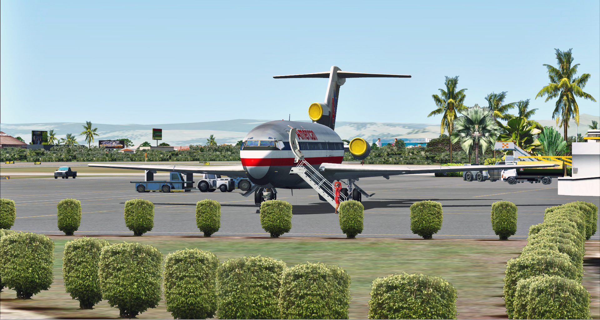

Graham Michael
Lead - Software Design & Development

Pacific Islands Simulation, LLC
Martinsburg, West Virginia USA

www.islandsim.com
www.islandsim.com/pis_forum
toksawe@gmail.com

© 2012 All Rights Reserved

A. BACKGROUND

Also known as Licenciado Gustavo Díaz Ordaz International Airport (IATA: PVR, ICAO: MMPR), Puerto Vallata International is located in Puerto Vallarta, Jalisco at the Pacific Ocean side of Mexico. The airport serves thousands of tourists each year and in 2011, the airport handled over 2.5 million passengers. The airport is named after President Gustavo Díaz Ordaz.

The top ten busiest routes out of Puerto Vallarta are Los Angeles, Pheonix, Houston, Dallas, San Francisco, Chicago, Denver, Minneapolis, Seattle and Calgary, in that order. Airlines servicing the airport include, Aeromexico, Air Canada, American, Air Transat, Alaska, Arkefly, Canjet, Delta, Enerjet, Frontier, Interjet, Magnicharters, Sun Country, Sunwings, Thomas Cook, United, USAir, Viva Aerobus, Virgin America, Volaris and Westjet.

Puerto Vallarta International has a 10,171ft runway and caters for all types of aircraft. Information specific to airport services, runway type, navigational equipment, lighting, etc, are included with product doc.

B. FACILITIES DIRECTORY
(NOT INTENDED FOR REALWORLD USE)

NOTE: Information listed below may not be current.

Airport Ident: MMPR
Airport Name: LICENCIADO GUSTAVO DIAZ ORDAZ INTL, Mexico
Location: Puerto Vallarta
Latitude: N2040.8 Longitude: W10515.3
Field Elevation: 23' Variation: E8º as of 01/06
Time Zone: UTC-6(-5DT)
Daylight Savings: First Sunday in April to the last Saturday in October
Customs: Airport Of Entry

DISTANCE from:
KTEB to MMPR = 1995 nm
KMIA to MMPR = 1408 nm
KORD to MMPR = 1551 nm
KDAL to MMPR = 857 nm
KSEA to MMPR = 1808 nm
KLAX to MMPR = 1059 nm

AIRPORT TYPE:
Active civil airports controlled and operated by civil authorities primarily for use by civil aircraft, although military may have landing privileges and/or contract rights. Minimum facilities are available which include: control tower (or some similar control system, such as a Flight Service Station which issues clearances and advisories when there is no tower or the tower is not in operation), lighting (may be flare pots, etc.), petrol, oils and lubricants (POL), and facilities for organizational maintenance or better.

RUNWAY INFORMATION:
Runway Ident: 22 /04
Runway Length: 10171
Runway Width: 148
Runway Surface: ASPHALT, ASPHALTIC CONCRETE, TAR MACADAM, OR BITUMEN BOUND MACADAM (INCLUDING ANY OF THESE SURFACE TYPES WITH CONCRETE ENDS).
Runway PCN Rating: 048FBXT - Flexible, Subgrade-MEDIUM, Tire Pressure-MEDIUM LIMITED TO 217 PSI
Runway PCN Evaluation Method: Technical Evaluation.
Runway Open: YES
Runway 22 Information  Runway True Heading: 227º  Takeoff Distance Available: 10356  Landing Distance Available: 10171  Runway Latitude: N2041.4  Runway Longitude: W10514.6  Runway Elevation: 15'  Runway Slope: 0º  Runway TDZE:  Runway Lighting: HIRL, PAPI | Runway 04 Information  Runway True Heading: 47º  Takeoff Distance Available: 10356  Landing Distance Available: 10171  Runway Latitude: N2040.2  Runway Longitude: W10515.9  Runway Elevation: 12'  Runway Slope: 0º  Runway TDZE: N/A  Runway Lighting: HIRL, SALS or SALSF, PAPI

COMMUNICATION INFORMATION
APPROACH CONTROL - VALLARTA APP
121.3 119.0
AUTOMATIC TERMINAL INFORMATION SERVICE - VALLARTA ATIS (Opr 1300-0600Z)
127.5
TOWER - VALLARTA TWR
118.5
OPERATING HOURS
AUTOMATIC TERMINAL INFORMATION SERVICE - Opr 1300-0600Z
AIRPORT NAVAIDS
PVR - VALLARTA (VOR-DME) - ON FIELD
Rotating Beacon: YES

Source: http://www.fltplan.com/AirportInformation/Airport.cgi?MMPR

C. PRODUCT FEATURES

- Accurate airport terminal buildings;
- Specific photoreal coverage of Banderas Bay/Valley area including Old town Puerto Vallarta and Nuevo Vallarta (Nayarit district);
- Custom runway and ground/apron textured polygons, and appropriate markings;
- Custom vegetation, 3D grass, and objects;
- Custom 38m mesh for the Banderas Bay/Valley terrain surroundings. (MMPR is also compatible with any payware or freeware mesh for Mexico/Central America);
- Landmark Puerto Valarta hotels/resorts along nearly 30 miles of white sandy coastline
- Complete hand textured coloration of land and waterclass typical of Jalisco State;
- Exceptional textured night lighting and effects;
- 15/30cm/pixel photoreal texture;
- Framerate-friendly (including full autogen enhancements for framerate fluidity using SDK annotator). This means all sliders to the right with very minimal fps impact;
- Radio navigation enhanced for instrument approaches (ILS/DME and VOR);
- MyTrafficX compatible for real-world schedules and airline liveries that frequent Puerto Vallarta;
- ....and more.

D. SYSTEM-SPECIFIC REQUIREMENTS

Puerto Vallarta International was developed on a medium system for medium to high-end computers, and was tested on WinXP, Vista and Win7 32/64 bit platforms with medium to high-end graphic cards. Specific requirements include:

- Microsoft Flight Simulator X (SP1, SP2/Acceleration)
- Pentium IV 2.6 GHz (2GHz Duo2Core Intel and above or equivalent advised)
- 1 GB RAM and above recommened
- 256 Mb DirectX 9/10 graphics card (512 Mb or higher recommended)
- Word for Windows or Adobe Acrobat® Reader 6 minimal to read and print the manual.
- Over 550mb of hard disk space

E. RECOMMENDED FSX SETTINGS
Frame rates from scenery complexity and autogen settings were averaged at 30fps and above. This includes moving sliders 100% to the right. Lower settings yielded much higher frames, but our recommendation is Dense to Very Dense for variable exceptional rates. Since the scenery is 15/30cm/pixel photoreal and comes with own 38m mesh, it is highly recommended that Mesh Resolution be set at 1 meter within FSX Display Settings (or slider adjusted 100% to the right). Texture Resolution should also be set at 30cm or above (or slider set 100% to the right).
Recommended AI Traffic requirements and settings:

There are AI boat traffic movement within Banderas Bay. To maintain a formidable and exceptional level of FPS, it is recommended that leisure boats be set at 30% or less.
AI road traffic is only found at/near the airport at major road trunks so as to save on FPS. Recommended setting is 40% or lower.

MyTrafficX from B Renk (developer) is our choice of payware AI air traffic engine especially to reflect compatibility with real-world schedules and airline liveries that frequent Puerto Vallarta International. So you need that to experience RW simulated AI traffic flow. Recommended setting for fluidity is 60% or less. The product is also compatible with Ultimate Traffic 2, other non-payware AI programs, and default the AI engine.

PRODUCT DISCLOSURE and DISCLAIMER

Similar to any Flight Simulator (FS) Addons, this product may have issues that are either default (Microsoft-related) or developer-related. Issues that are MS-related, whether documented or undocumented are many, but we can only speak for our product. Although there are no micro-stutters or huge lag in fps as tested, it is advisable to lower the Water Effects within FSX Display Settings to High 2x. and set Autogen down to respectable levels for fluidity. These are recommended for lower to medium-end systems, however the scenery is meant for sliders maxed at 100% peak for those computers who can afford the high level scenery design.

No technical issues were encountered during various beta tests, whether hardware or software- related. Instructions for installation of software are straightforward; however, venturing outside bounds of recommended installation and use is at sole discretion of End-User. We will not bear responsibility for issues resulting from installation of the product, in part or full, into former Flight Simulator platforms which includes FS2004 because the product is not backward compatible. Furthermore, we will not be held responsible if files are altered within software for any reason associated with End-User taste or choice.

The product is Non-refundable for these and various other reasons.

F. ACKNOWLEDGEMENT

As usual, we are deeply grateful to those who contributed to development of this product. The list includes:

1. Granger Michael - for providing photos and detail information on various Puerto Vallarta sites including resorts and airport surrounds.
2. Henry Pearce - for landclass and waterclass textures
3. Lance "Meshman" Tucker - for his Puerto Vallarta custom 38m mesh
4. Ken Alger - for testing product
5. Syed Shibli - for testing product
6. James Whitener - for testing product
7. Pete Bretler - for testing the product
8. Gregory Cedric - for testing product
9. Scott Smart - for advice/tutorial on "Population Density" creation

…and to those I may have inadvertently left out in this Acknowledgement, we highly value your contribution as well.

Graham Michael
Lead - Software Design & Development

MMPR AIRWAYS CHART

