XIAMEN GAOQI INTERNATIONAL

Created by Real-world Pilots for FSX Simmers

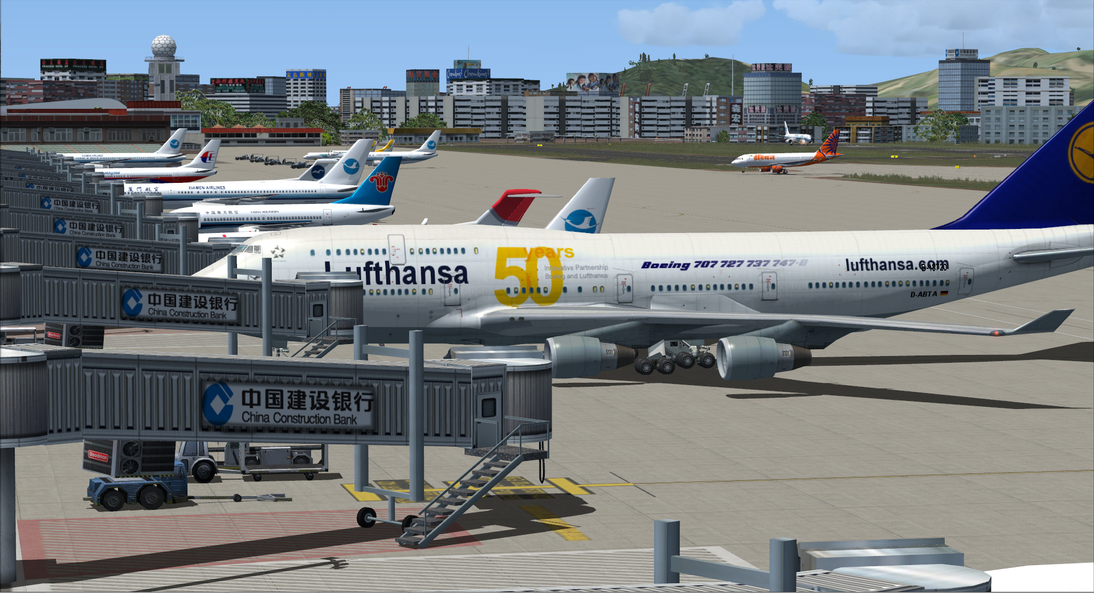

Graham Michael
Lead - Software Design & Development

Pacific Islands Simulation, LLC
Martinsburg, West Virginia USA

www.islandsim.com
www.islandsim.com/pis_forum
toksawe@gmail.com

© 2012 All Rights Reserved

A. BACKGROUND
Xiamen Gaoqi International Airport (IATA: XMN, ICAO: ZSAM) is the airport serving the city of Xiamen in Fujian Province, China. It is the main base of Xiamen Airlines and TAECO Engineering, an aircraft maintenance company. The airport is located on the north side of Xiamen Island. Construction of a new terminal started in October 2011 and is expected to be completed by 2014.
In 2011, Xiamen airport was the 9th busiest airport in China in terms of cargo traffic, and the 11th busiest in terms of passenger traffic with 15,757,049 passengers traffic movement.
Xiamen airport offers 75 air routes to 58 Chinese domestic cities and 17 international flights to North, Central and South America, Southeast Asian countries, Australia and Europe.
(Source: http://en.wikipedia.org/wiki/Xiamen_Gaoqi_International_Airport)

B. FACILITIES DIRECTORY
(NOT INTENDED FOR REALWORLD USE)

QuickFacts
Airport ICAO Code: | ZSAM
Airport IATA Code: | XMN
Airport Type: | A - Civil
Longitude/Latitude: | E 118° 07' 39.86"/N 24° 32' 38.53"  118.127739/24.544036
Elevation: | 59 ft / 17.98 m
Location: | Xiamen, Fujian, China
Magnetic Variation: | W 3°23.3' (2008-04)
Time Zone: | UTC+8

Airport Communications
Type | Name | Freq 1 | Freq 2 | Freq 3 | Freq 4 | Freq 5
Approach Control | XIAMEN APP | 121.35 M | 119.05 M
Automatic Terminal Information Service | ATIS | 126.25 M
Ground Control | XIAMEN GND | 121.7 M
Tower | XIAMEN TWR | 118.25 M | 130.0 M

Runway Information

Runway 05/23
Dimension: | 11155 x 148 ft / 3400.0 x 45.1 m
Surface: | Asphalt, asphaltic concrete, tar macadam, or bitumen bound macadam.
 | Runway 05 | Runway 23
Longitude: | 118.114517 / E 118° 06' 52.26" | 118.140967 / E 118° 08' 27.48"
Latitude: | 24.534589 / N 24° 32' 04.52" | 24.553411 / N 24° 33' 12.28"
End Elevation: | 56.7 ft | 35.1 ft
Alignment: | 055.0 | 235.0
Slope: | -0.2 | 0.2
Touchdown Zone Elev.: | 58.7 | 39.0
Displaced Threshold: | 490 ft | 660 ft
Lighting System 4: | High Intensity Runway Lights | PAPI - Precision Approach Path Indicator
Lighting System 5: | ALSF-2
Lighting System 6: | PAPI - Precision Approach Path Indicator

Remarks
- Caution - Bird haz.
- Customs/Agriculture/Immigration - Avbl.
- Fuel - (NC-J)
- Operating Hours - Opr HS or O/R.
- Restricted - Deviations SE of ext rwy cntr line not permitted. 180 turns on rwy proh. SSR transponder req for tkof and ldg.
(Source: http://www.airport-data.com/world-airports/ZSAM-XMN/)

PRODUCT FEATURES

- Accurate airport terminal buildings, hangars (Taeco Engineering and Xiamen Airlines) and freight warehouses;
- Haicang Bridge and Wu Yuan Bridge
- Custom vegetation;
- Volumetric grass
- Realistic night lighting ambiance;
- 15cm/pixel photoreal landclass.
- Season coloration typical of the region;
- Framerate-friendly
- Static vehicles and airplanes
- AI boats and road traffic
- Weathered runway and apron markings;
- Custom highrise buildings correctly placed along approach paths;
- ....and more.

SYSTEM-SPECIFIC REQUIREMENTS

Xiamen Gaoqi International Airport was developed on a medium system for medium to high-end computers, and was tested on WinXP, Vista and Win7 32/64 bit platforms with medium to high-end graphic cards. Specific requirements include:

- Microsoft Flight Simulator X (SP1, SP2/Acceleration)
- Pentium IV 2.6 GHz (2GHz Duo2Core Intel and above or equivalent advised)
- 256 Mb DirectX 9 graphics card (512 Mb or higher recommended)
- Word for Windows or Adobe Acrobat® Reader 6 minimal to read and print the manual.
- 450MB of hard disk space required

RECOMMENDED FSX SETTINGS
Frame rates from scenery complexity and autogen settings were averaged at 40fps and above. This includes moving sliders 100% to the right. Medium settings yielded much higher frames, but our recommendation is Dense to Extreme Dense for exceptional rates. Since the scenery is 15/30cm/pixel photoreal, it is highly recommended that Mesh Resolution be set at 1 meter within FSX Display Settings (slider 100% to the right) and mesh complexity set at 100%. Texture Resolution should also be set at 30cm and above (or slider 100% to the right).
Recommended AI Traffic settings:

There are AI boat traffic within vicinity of Xiamen Island. To maintain a formidable and exceptional FPS levels, it is recommended that leisure boats be set at 20% or less.

AI Road traffic should be set at 20% or less.

MyTrafficX (5.4) is our preferred AI traffic engine. However, the product is compatible with any other third party payware and/or freeware AI engines as well. Recommended setting for best performance is 60% or less.

PRODUCT DISCLOSURE and DISCLAIMER

Similar to any Flight Simulator (FS) Addons, this product may have issues that are either default (Microsoft-related) or developer-related. Issues that are MS-related, whether documented or undocumented are many, but we can only speak for our product. Although there are no micro-stutters or huge lag in fps as tested, it is advisable to lower the Water Effects within FSX Display Settings to High 2x. and set Autogen down to respectable levels for fluidity. These are recommended for lower to medium-end systems.

No technical issues were encountered during various beta tests, whether hardware or software- related. Instructions for installation of software are straightforward; however, venturing outside bounds of recommended installation and use is at sole discretion of End-User.

We will not bear responsibility for issues resulting from installation of the product, in part or full, into former Flight Simulator platforms which includes FS2004 because the product is not backward compatible. Furthermore, we will not be held responsible if files are altered within software for any reason associated with End-User taste or choice.

The product is Non-refundable for these and various other reasons.

ACKNOWLEDGEMENT

As usual, we are deeply grateful to those who contributed to development of this product. The list includes:

1. Huo Chang - for providing photos
2. Yuxiaobin (via airliners.net) - for photos and description
3. Kai Uwe Pel (simflight, China) - for assistance with Chinese language characters
4. Henry Pearce - for landclass and waterclass textures
5. Lance "Meshman" Tucker - for testing product
6. Ken Alger - for testing product
7. Syed Shibli - for testing product
8. James Whitener - for testing product
9. Pete Bretler - for testing the product
10. Gregory Cedric - for testing product

…and to those I may have inadvertently left out in this Acknowledgement, we highly value your contribution as well.

Graham Michael
Lead - Software Design & Development

CHARTS

Charts courtesy of Jeppesen. Below is a sample only. For complete/required charts, go get them here:

http://wenku.baidu.com/view/6edade08763231126edb1111.html

